8. LISTENING
Listen to a person giving some advice about online shopping. Complete the following sentences:
1. Day ___by_ day
2. If you are, there are steps you can _take ____
3. Be sure to include ___delivery_____ costs in your budget.
4. What are the must-have product ____features___?
5. Read online reviews from other people who bought the __item___
6. Read a few reviews so you’re not relying __on__ just one source
7. Look for online ___coupon codes_
8. The ___law___ requires sellers to ship items within 30 days of the sale
9. …some companies will __cap __ your liability at $50
10. The ‘s’ __stand__for__ ‘secure’
11. If you have a problem with an online purchase or charge, try to _ __work it out__ with the seller first.
12. If you can’t resolve the problem, __file____ a complaint with the Federal Trade Commission.

Read the following text.
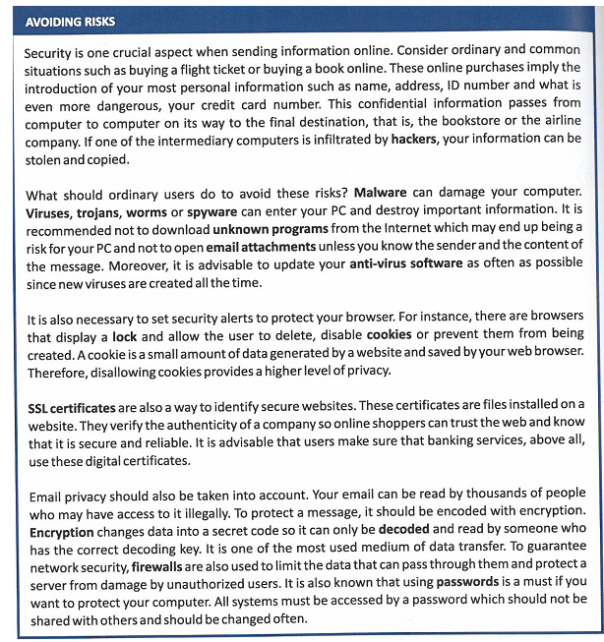

- Answer the following questions according to the information in the text.

- Why is it risky to buy a flight ticket online?
Because online purchages imply the introduction of your personal information.
- How can you protect your PC from malware?
Not to download unknown programans from the internet, not to open emails attachments unless you know the sender, and update your anti-virus software.
- Why is it advisable to disallow cookies?
Because it is an amount of data that is saved in your web browser.

- Why do online shoppers make sure that some websites use SSL certificates?
SSL certificates are important for a webs that are reliable and secures, like a banking web
- Can messages be decoded by any user?
No, you should have authorised user, also you must have a password to save your computer system.
2. Say if these sentences are true or false. Justify your answers.
- Buying online is always dangerous for online shoppers.
false
- Users can open email attachments provided that they know their sender.
true
- Ordinary users can disable cookies to protect their computers.
true
- SSL certificates are used by banking services to prove they exist, and they are real.
true
- Decryption converts encrypted data back into its original form.
true
- Firewalls are used to transfer data.
false
3.Look for words in the text that have these meanings.
- Acquisitions: __purchases________________
- Prevent: ________avoid______________
- Install, apply: _________set__________
- Consequently: _________therefores__________
- To ensure: __________make sure____________
4.Find words in the text that have opposite meanings.
- Irrelevant: ____necessary_______________
- Safe: ____________dangerous ___________
- Allowing: ______preventing _____________
- Lower: __________higher_________
- Mistrust: _________trust___________
- Unreliable: _________reliable________

